**UiPath Integration Service: Input Arguments & Event Triggers**

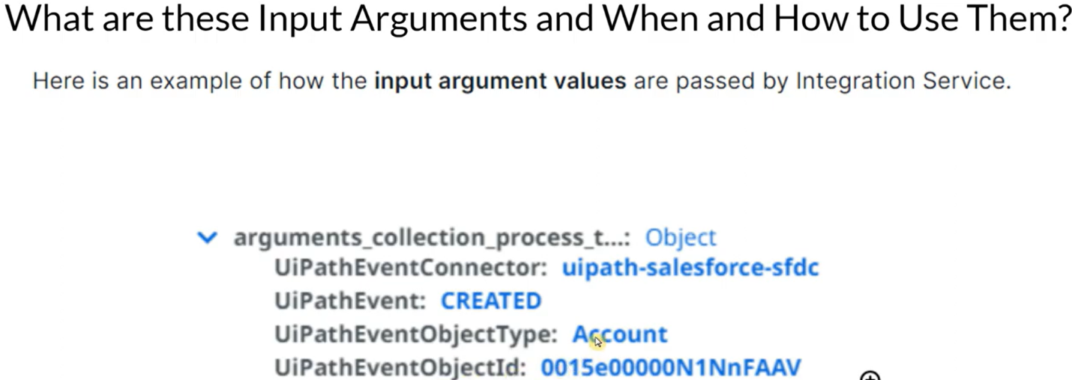

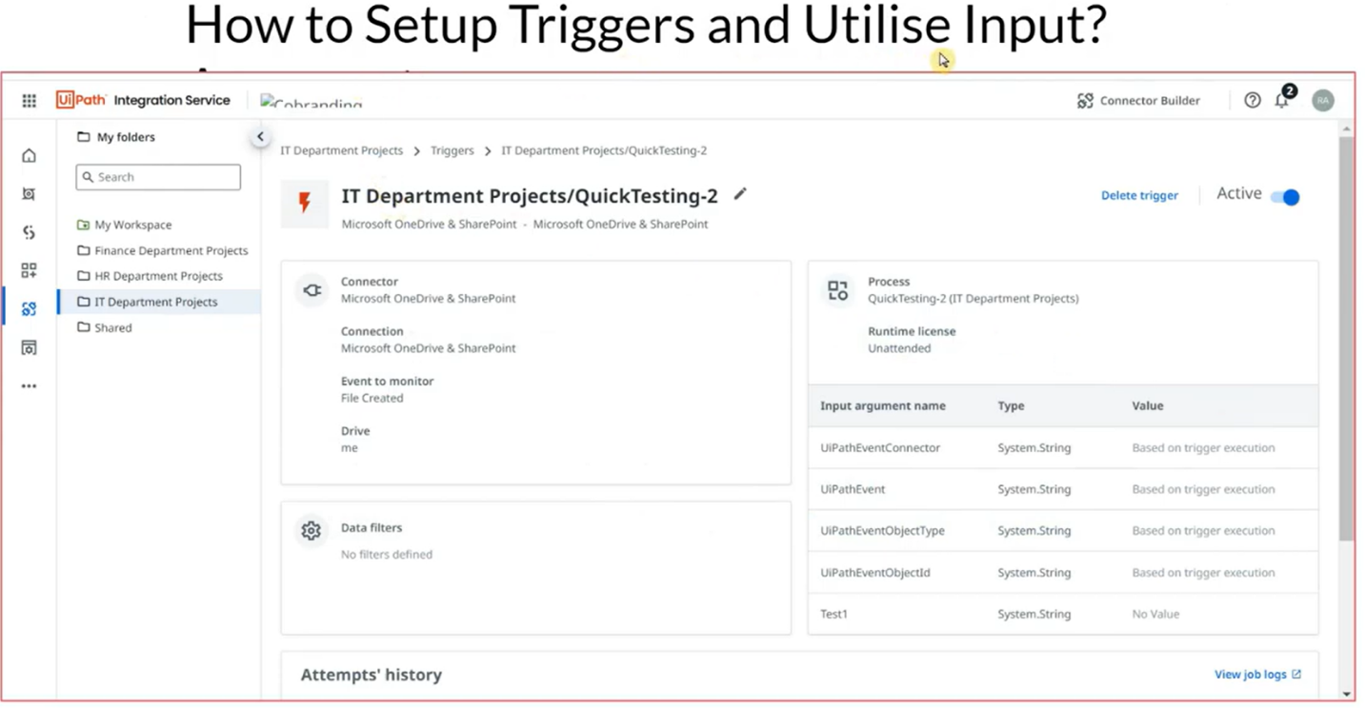

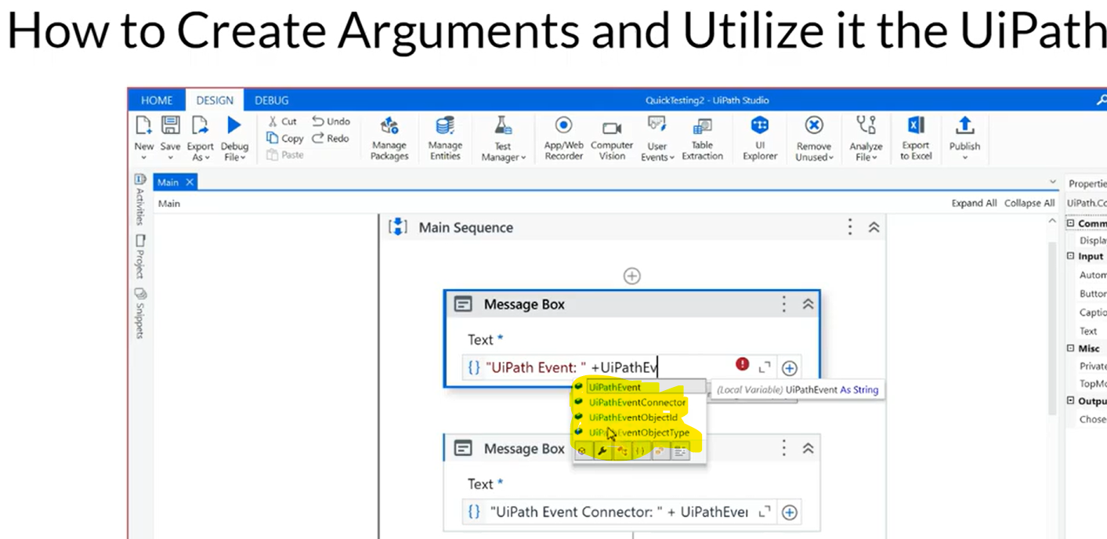

1. Create connection to OneDrive in Integration Service.
2. Create a trigger - the moment a new file is created, automation should start.

When trigger runs, it creates some information for us. Refer documentation: <https://docs.uipath.com/integration-service/automation-cloud/latest/user-guide/triggers>

* **UiPathEventConnector**
* **UiPathEvent**
* **UiPathEventObjectType**
* **UiPathEventObjectId**

These will be the default **IN arguments** to be created in studio by us in our automation & we should use with same naming as it is.

1. Log a message or message box with all the 4 arguments to see what kind of value it carries.

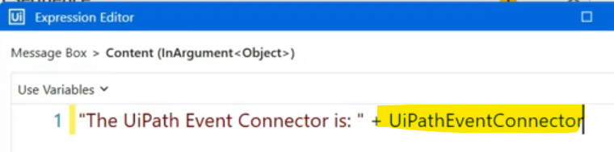

1. Publish this process to orchestrator.

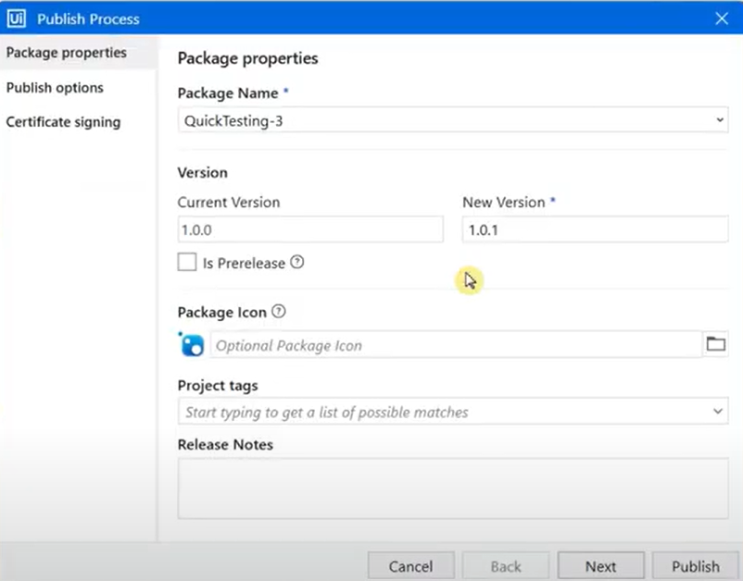

1. Once the code is published to orchestrator, let's create a process for this package.

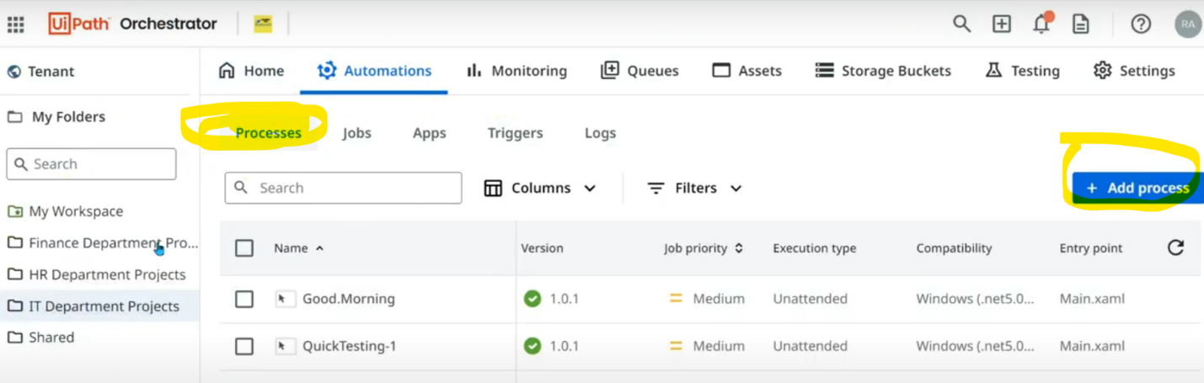

Select the package name & hit next, next, next & create.

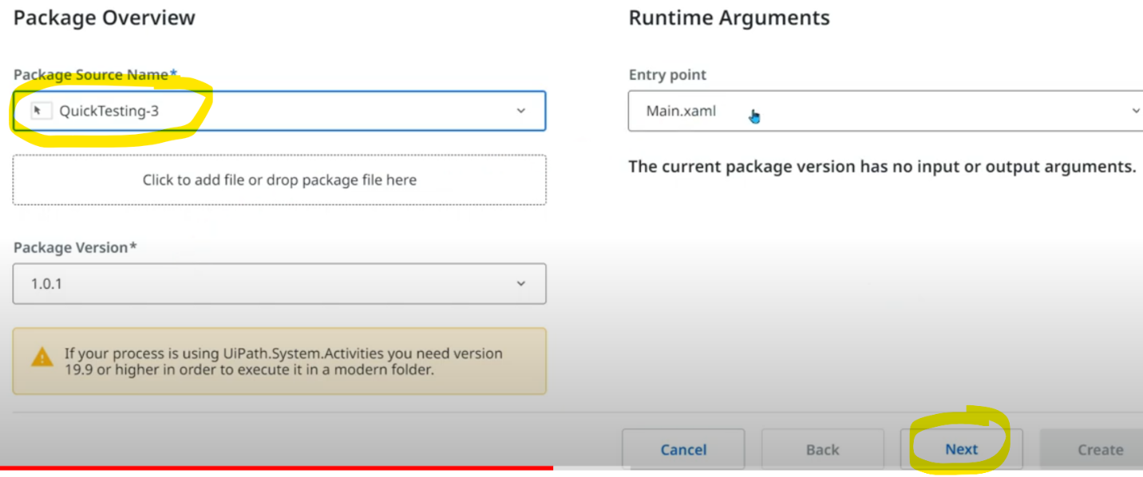

1. Create a trigger by giving connector, it's name, event, drive, runtime license & automation name.

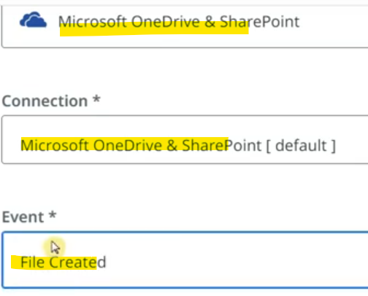

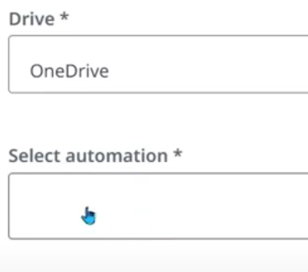

Before hitting on Add trigger after filling all these details, the moment you select the project name, it shows all the arguments associated with that project.

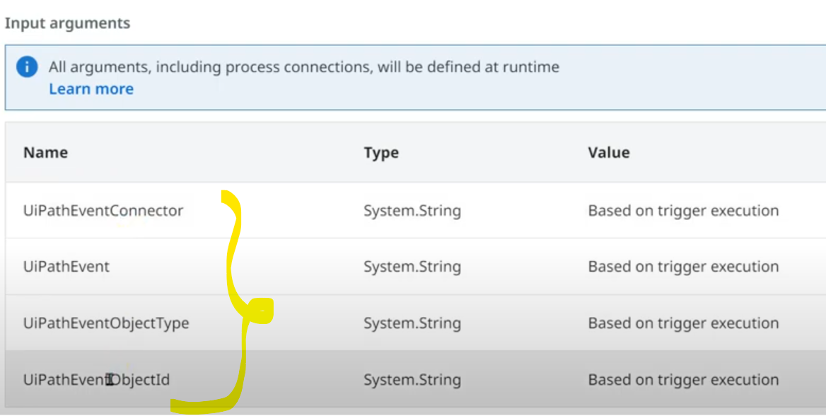

Once trigger is created, change the polling to 1 minute as we are monitoring file creation in OneDrive.

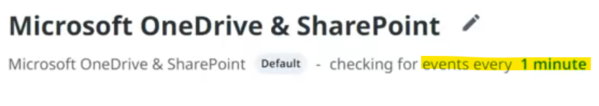

Let's create a new file in OneDrive & we can see the associated automation with this trigger has started & displaying 4 message boxes where we have asked it to show what are those 4 default argument values ?

* **UiPathEventConnector:** using this data, we can make use of switch activity & perform next steps. If connector is microsoft, follow so & so, else follow so & so steps.
* **UiPathEvent:** Helps in understanding type of event occurred.
* **UiPathEventObjectType:** If we select "file created" in event then object type will be File. If event is "folder created" then object type will be folder.
* **UiPathEventObjectId:** It provides unique identifier for the object involved in the event.

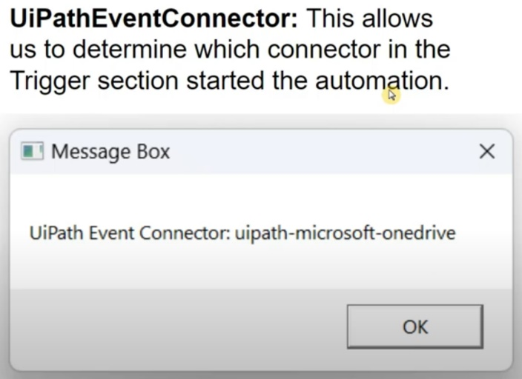

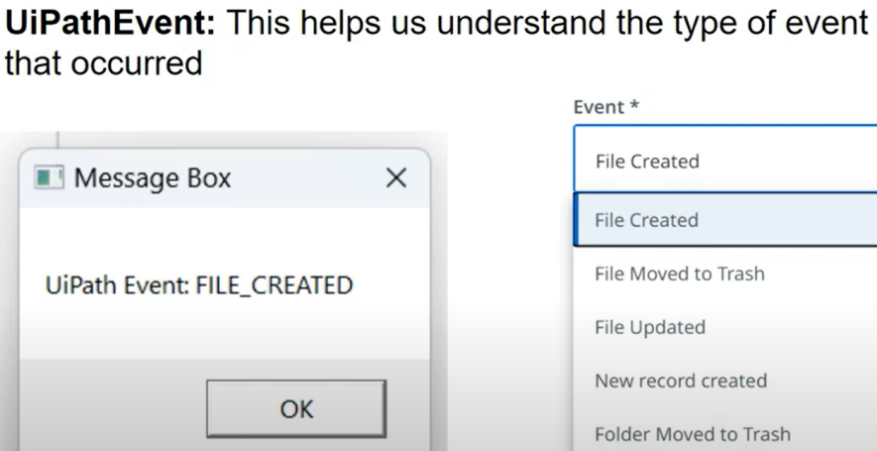

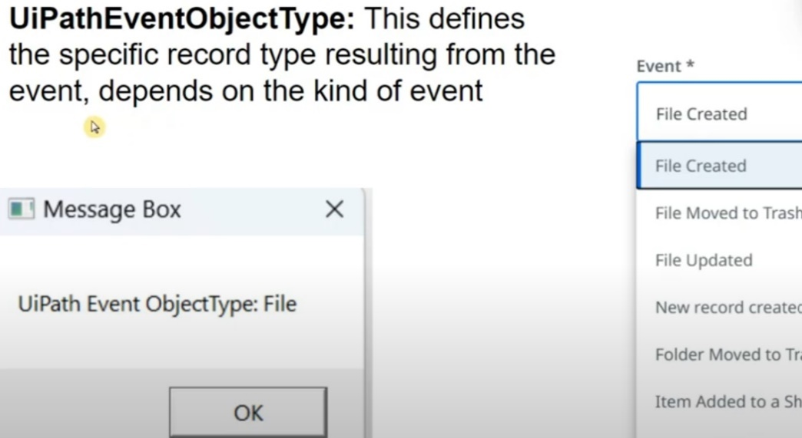

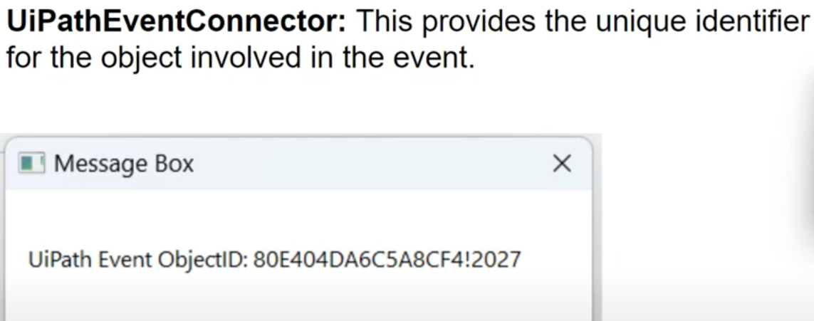

**UiPath Integration Service: Data Filters in Triggers**

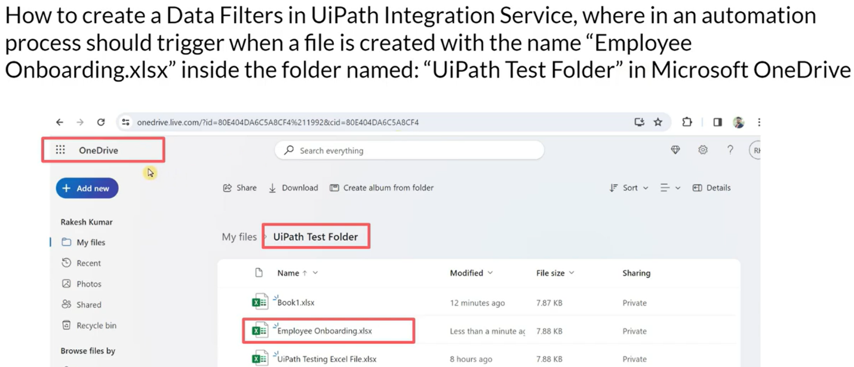

1. Create trigger.

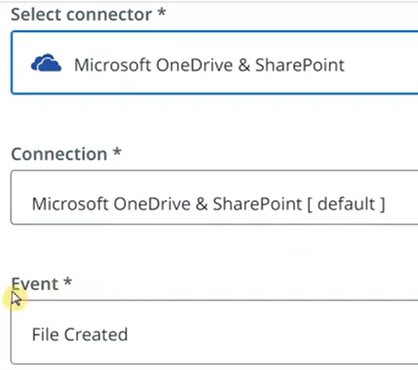

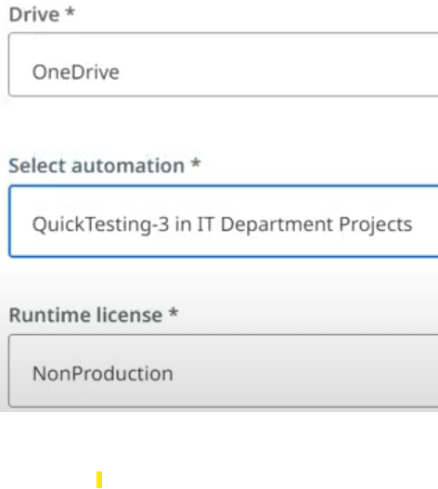

In Arguments popup automatically after choosing the automation project. We have seen about the arguments earlier chapter, let's add FILTER condition now.

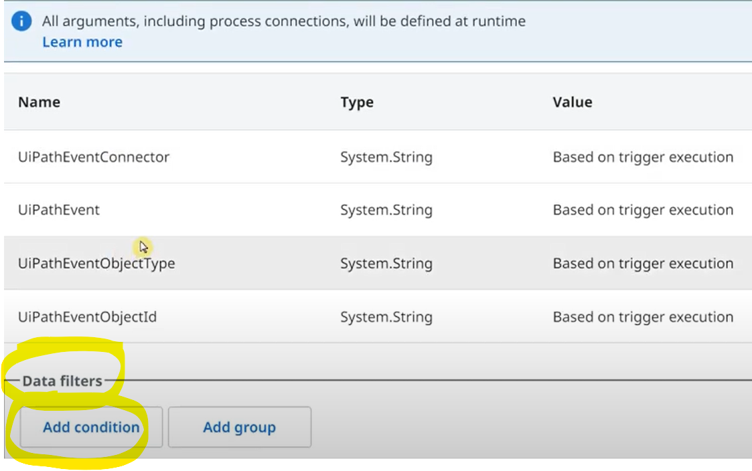

We have selected conditions & values from dropdown like below.

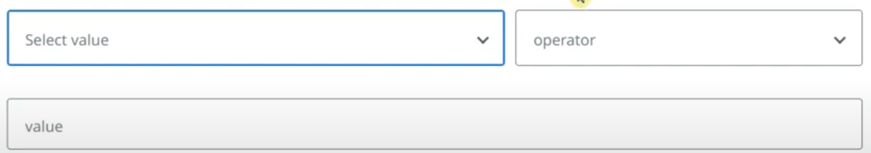

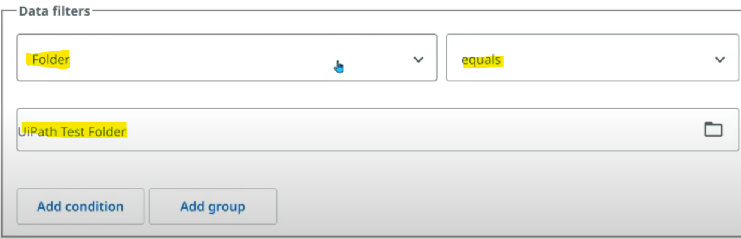

We are selecting one more condition as below. Note to include file extension as well.

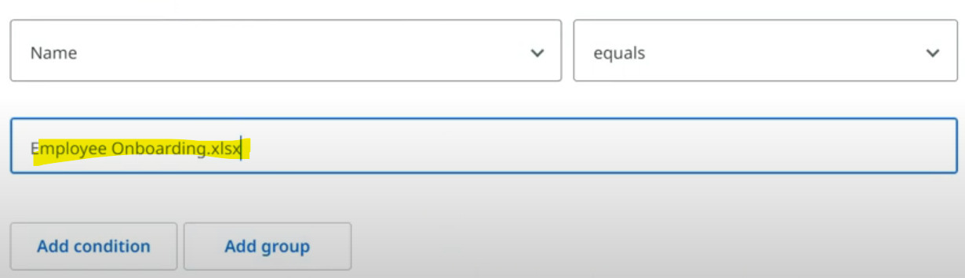

Once the trigger has got created, we can see data filters like below.

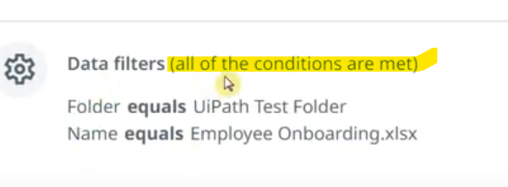

1. Set polling interval to 1 min
2. Create files with .docx & .ppt & check inside & outside the asked folder. Finally create .xlsx file inside that folder & check for trigger run.

**UiPath Integration Service: Customizing trigger polling interval**

<https://docs.uipath.com/integration-service/automation-cloud/latest/user-guide/triggers>

<https://docs.uipath.com/integration-service/automation-cloud/latest/user-guide/triggers#polling-interval>

NOTE:

1. Default time is 5 minutes & is configurable.
2. Min polling time - 1 min & max - 24 hours
3. 1 connection can have multiple triggers but 1 trigger will have only 1 connection & hence only 1 polling interval.
4. Changing the polling interval will affect all of its associated triggers.

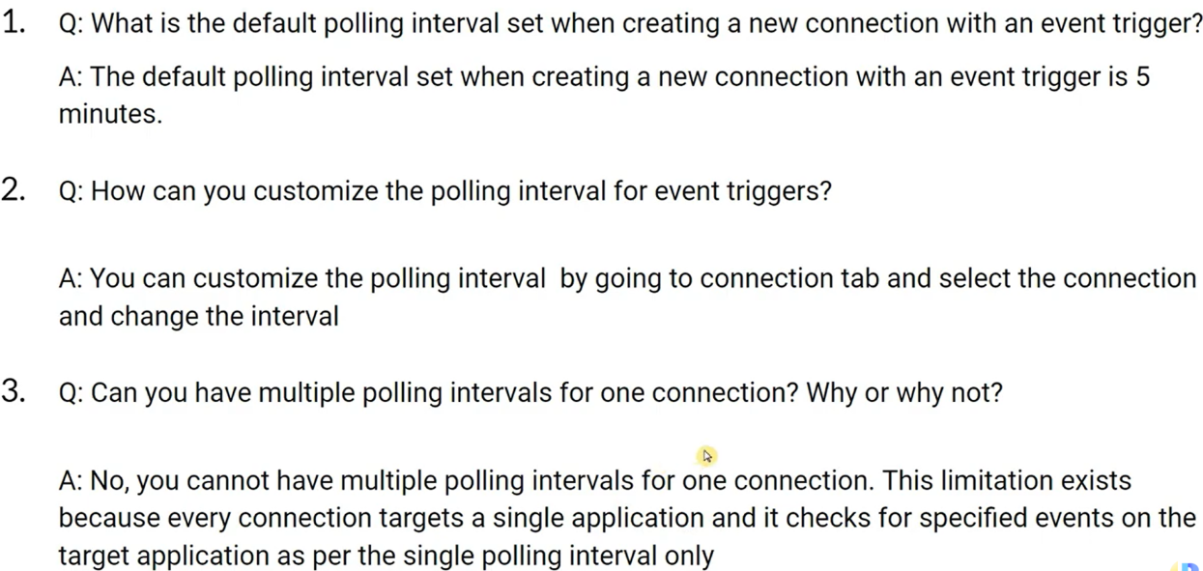

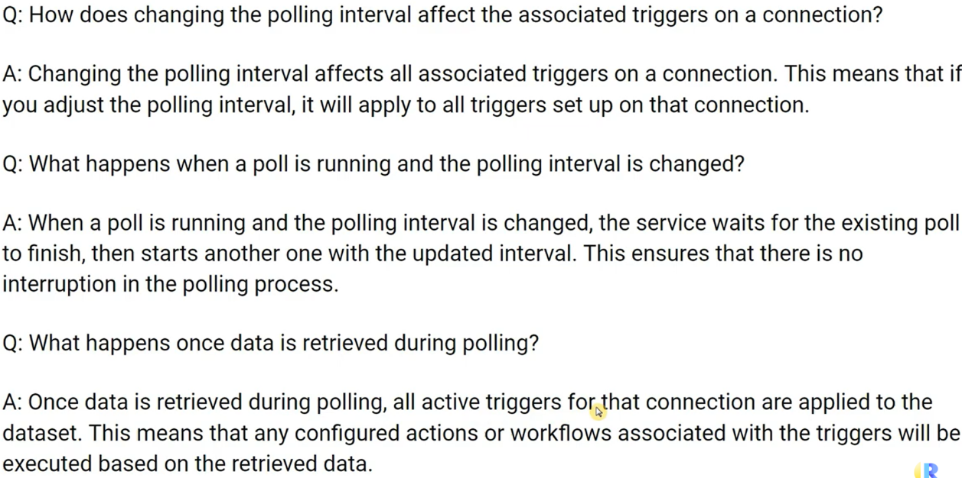

**UiPath Integration Service: Key Insights: Triggers**

<https://docs.uipath.com/integration-service/automation-cloud/latest/user-guide/triggers>

NOTE:

1. Triggers are only supported in Modern folders
2. In trigger history, the trigger status -

The Successful state only indicates that the job was successfully launched. It does not reflect whether the job was successfully executed to the end or not.

In case a job fails to start, its State will appear as Failed. Hover with the mouse cursor over the Failed state to view the error message.

1. To check if a job was successfully executed, click the View job logs button. It will redirect you to Orchestrator, where all the necessary information on job execution is displayed.

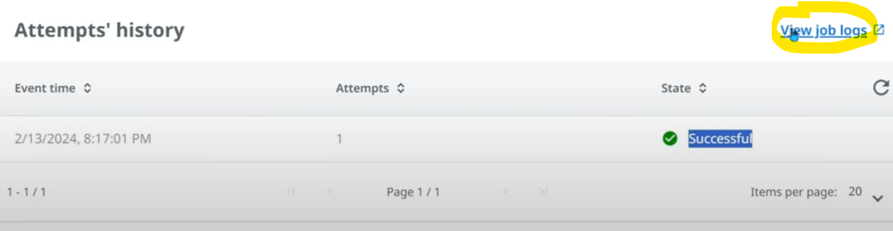

1. **Automatically disabling a trigger upon failure**

* **A trigger is disabled and set to error state if you are not able to start the job after 11 attempts (~34 hours) for a single event or if the job does not start for the last 100 events.**
* **The 10 retries for every event are done with an exponential back-off strategy. Each subsequent retry attempt comes after a delay twice as long as the previous attempt.**

**UiPath Integration Service: Key Insights: Integration Service Introduction Page**

<https://docs.uipath.com/integration-service/automation-cloud/latest/user-guide/introduction>

**REFER THE LINK WITHOUT FAIL**

UiPath Integration Service is the component of the UiPath Platform that makes the automation of third-party applications much easier by standardizing authorization and authentication, helping you manage API connections and also allowing faster integration into SaaS platforms.

**UiPath Integration Service: Key Insights: Integration Service Connectors Page**

<https://docs.uipath.com/integration-service/automation-cloud/latest/user-guide/connectors>

**REFER THE LINK WITHOUT FAIL**

Types of connectors:

* **Official**: generally available connectors
* **Preview**: available for public review. ome changes are yet to happen to the connector, not completely available in the market
* **Custom**: Built using connector builder

**UiPath Integration Service: Key Insights: Integration Service Connections Tab**

<https://docs.uipath.com/integration-service/automation-cloud/latest/user-guide/connections>

**REFER THE LINK WITHOUT FAIL**

Connection is a task created between a single user & external application.

NOTE:

1. If connection is created on shared folder, all users having access with the folder can use the connections in their automations. Also connections can be edited by all of them.

Multi-Authentication:

We can find this while we create connection through Integration service & during authentication, we can find in settings tab.

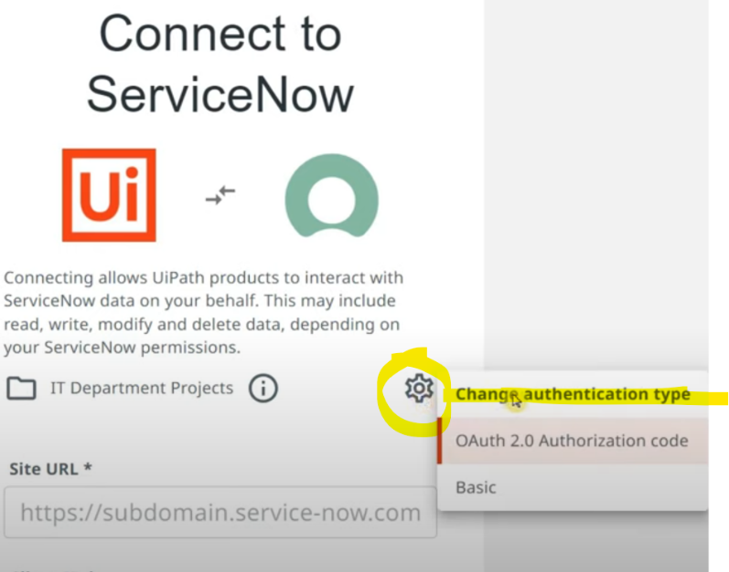

**UiPath Integration Service: Building Your Custom Connector**

<https://docs.uipath.com/integration-service/automation-cloud/latest/user-guide/connector-builder-about>

We need to decide on which application we need to build connection.

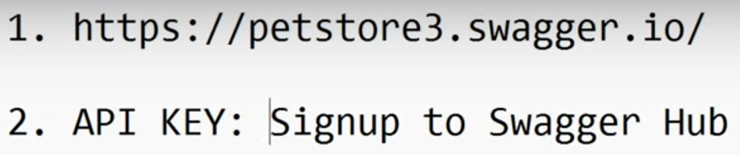

Let's choose Petstore from Swagger. It is a kind of small data base which gives information about pets if we specify ID.

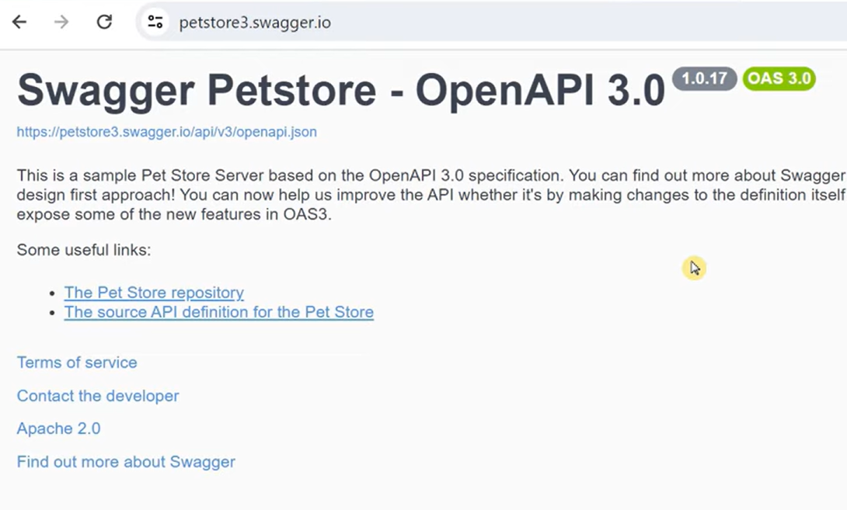

To get API key, we need to sign in.

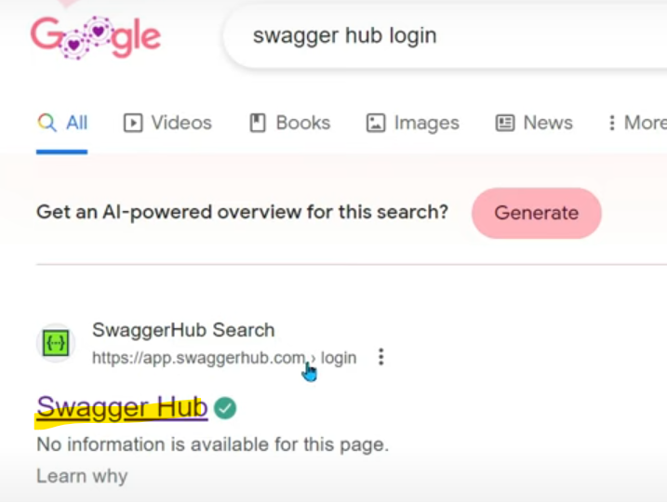

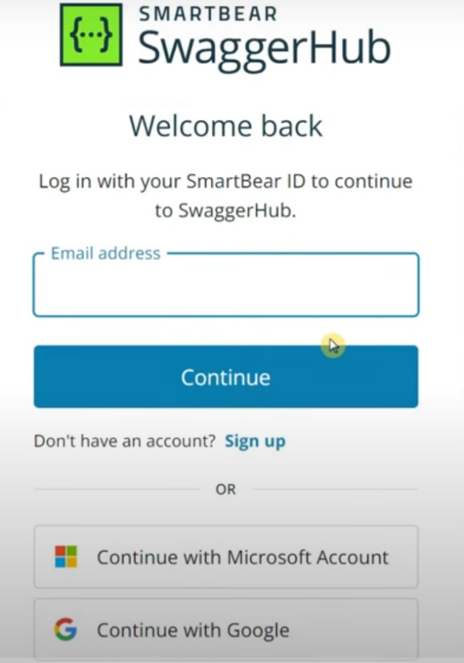

Once we sign in, we see the below dashboard.

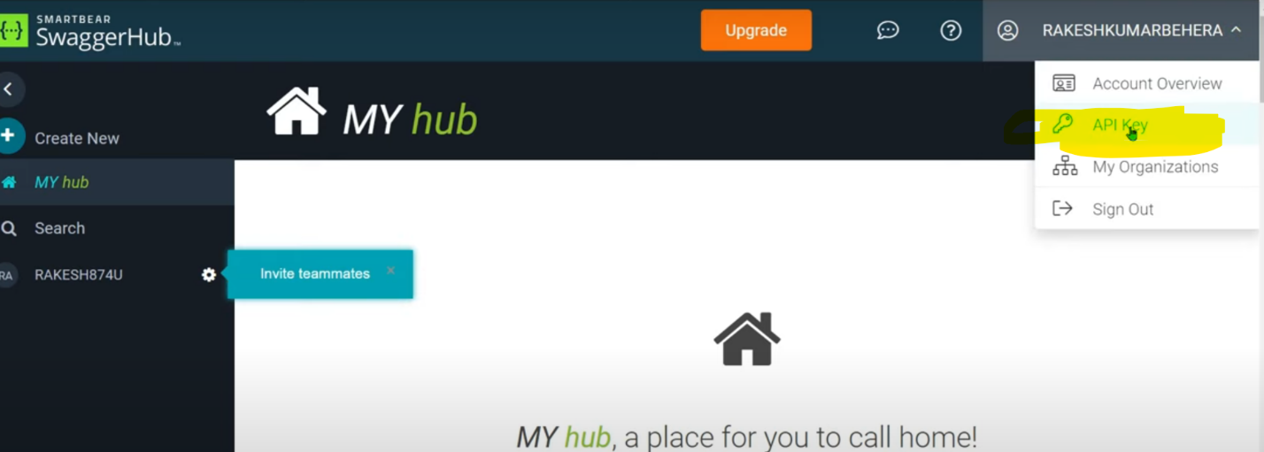

Here we find API key.

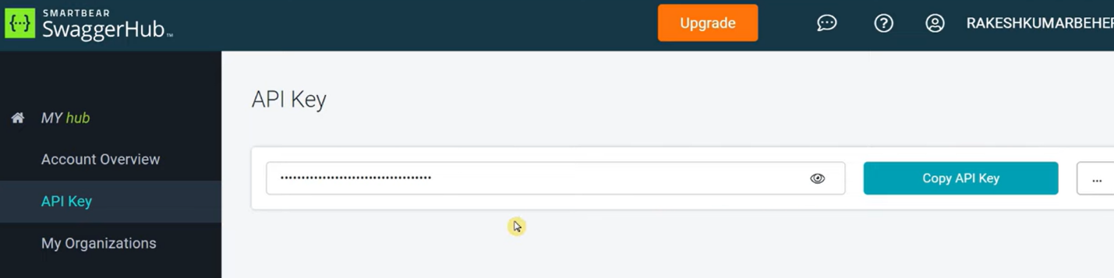

To access connector builder, go to Integration services. There are 2 ways to create as below.

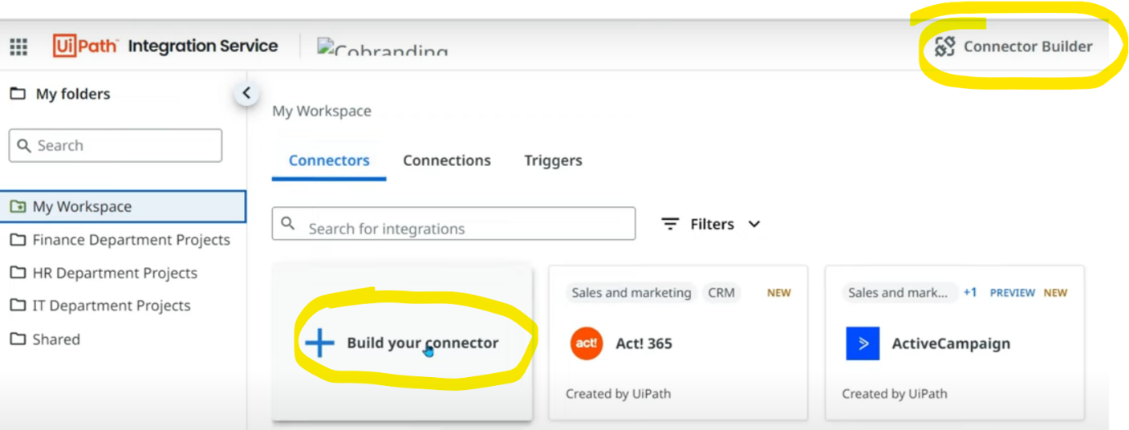

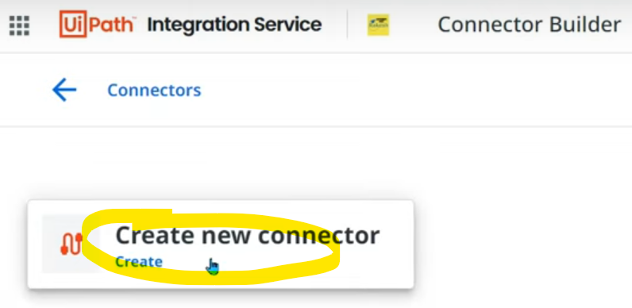

Let's use the below option for this demo.

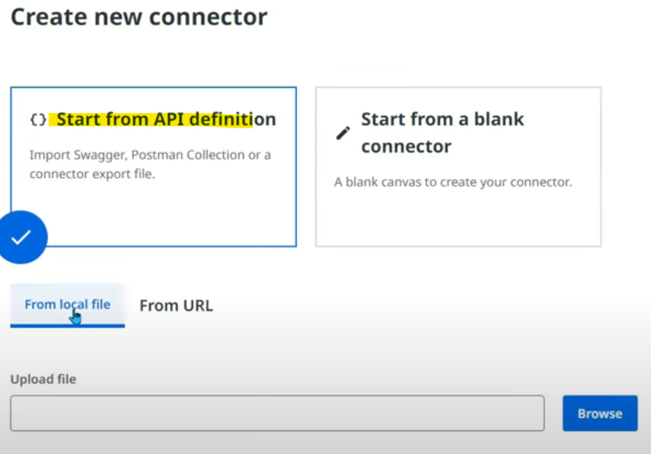

What do you mean by API definitions. Swagger has so many API definitions.

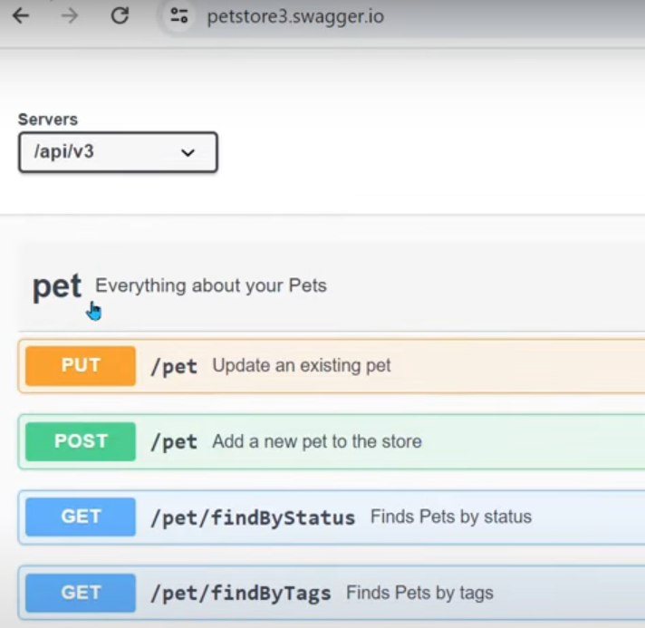

Once we select API definition, we get 2 options again - From local file & From URL.

**FROM URL:**

In the website we have this JSON URL as below.

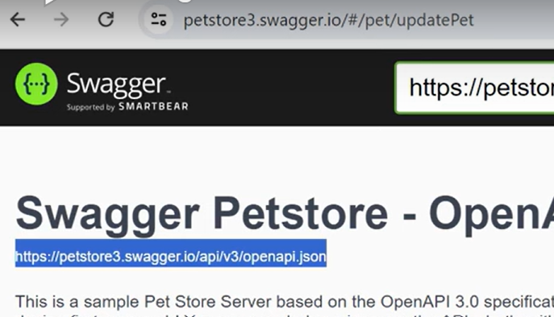

Copy that & open in another tab. We see below

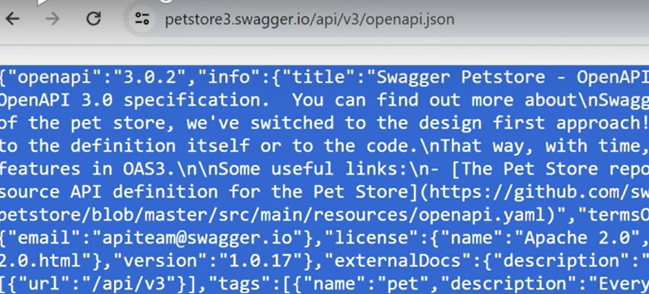

Copy whole thing & save in a notepad file & save as json format.

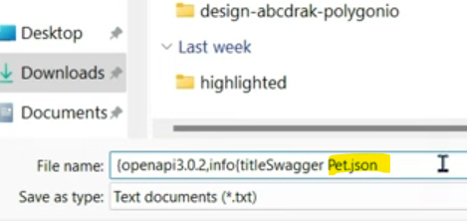

So, FROM LOCAL FILE option : we can browse this above file and for FROM URL option: we can pass the url directly.

Now it has pulled all the details on its own.

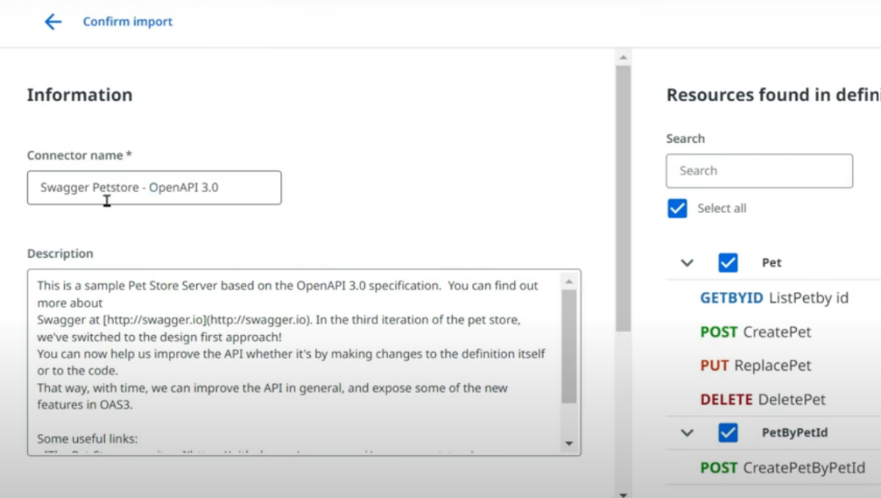

Once you click create button, below page appears indicating the connector isn't created yet & we need to pass values in these below 3 tabs.

**Info**: will be auto populated.

**API type**: REST" auto populated (REST-**representational state transfe**r is a way to transfer data from client to server and vice versa)

**Description**: auto populated

**Icon**: we can give an icon how this connector should be seen.

**Catalog preview**: by default this icon will be displayed.

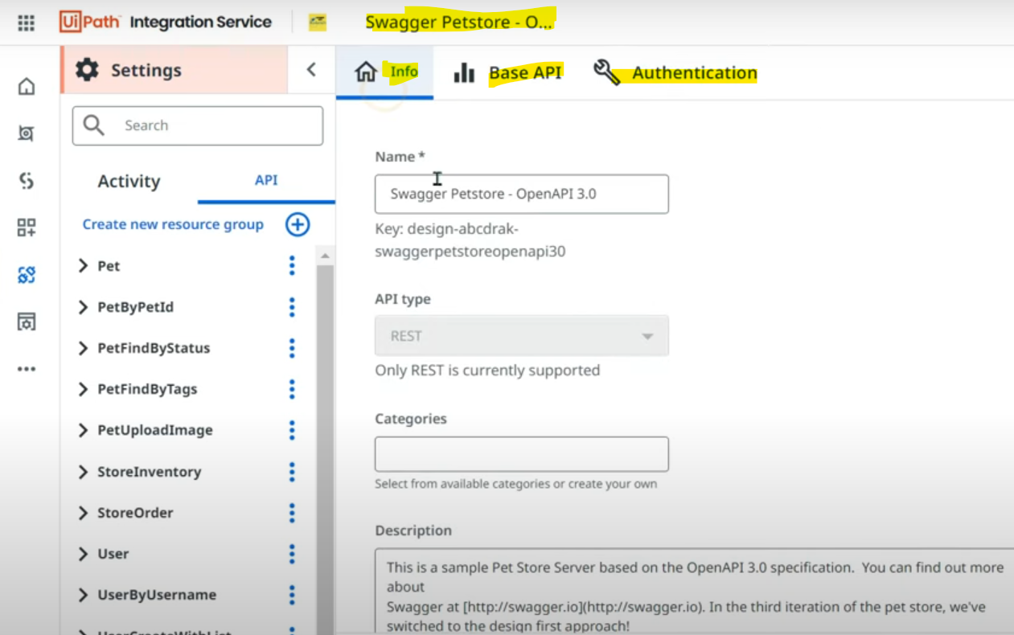

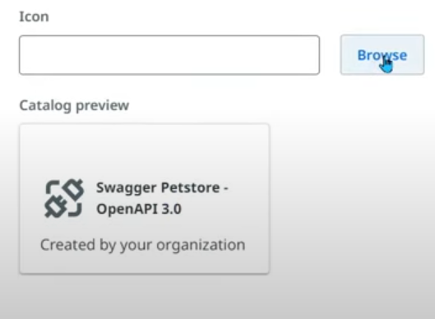

**Base API tab:**

The blue highlighted part becomes base API (until the version in any url). So until the version will be the base api & then next, we can add definitions to fetch/update/remove based on the requirement.

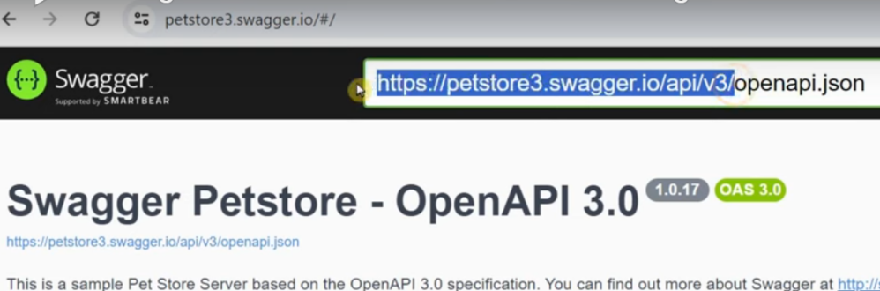

Enter the base API without "/" & save the connector.

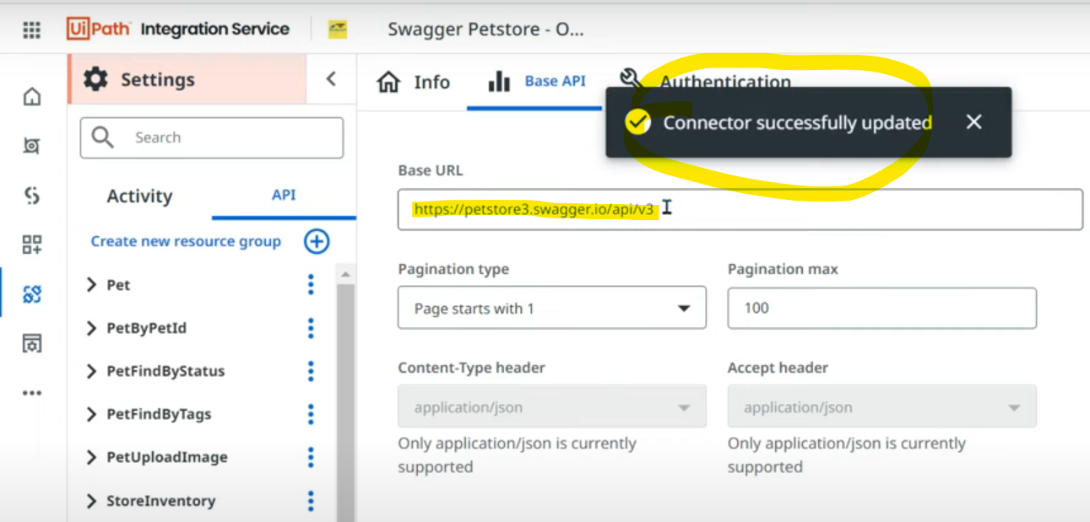

**Authentication Tab:**

When you are accessing something, you need permission right so that application understands that we are the right authorized user.

There are different authentication methods available.

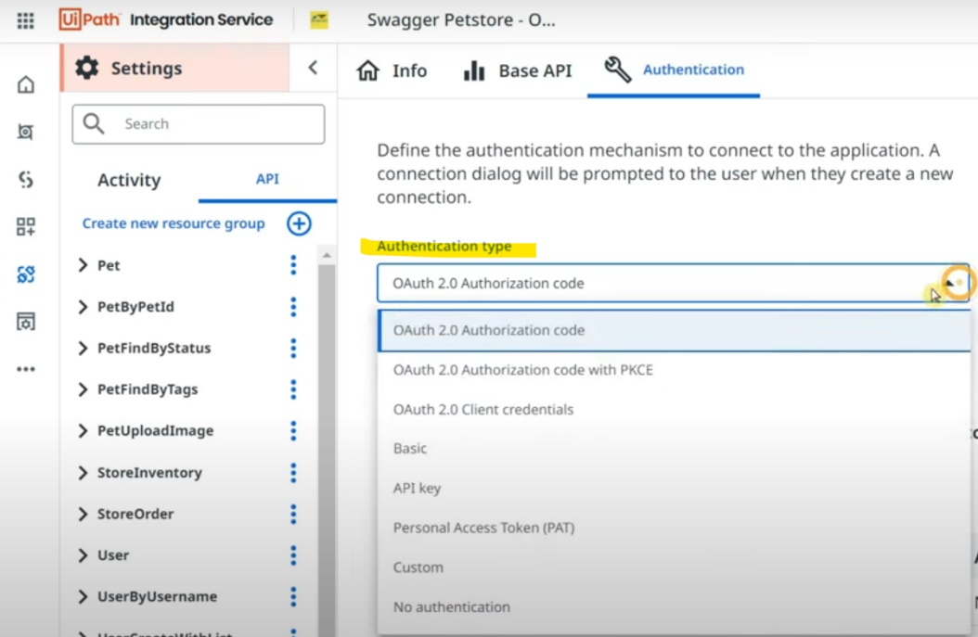

Suppose you select Basic, it asks for username & connection. Click on "Add connection"

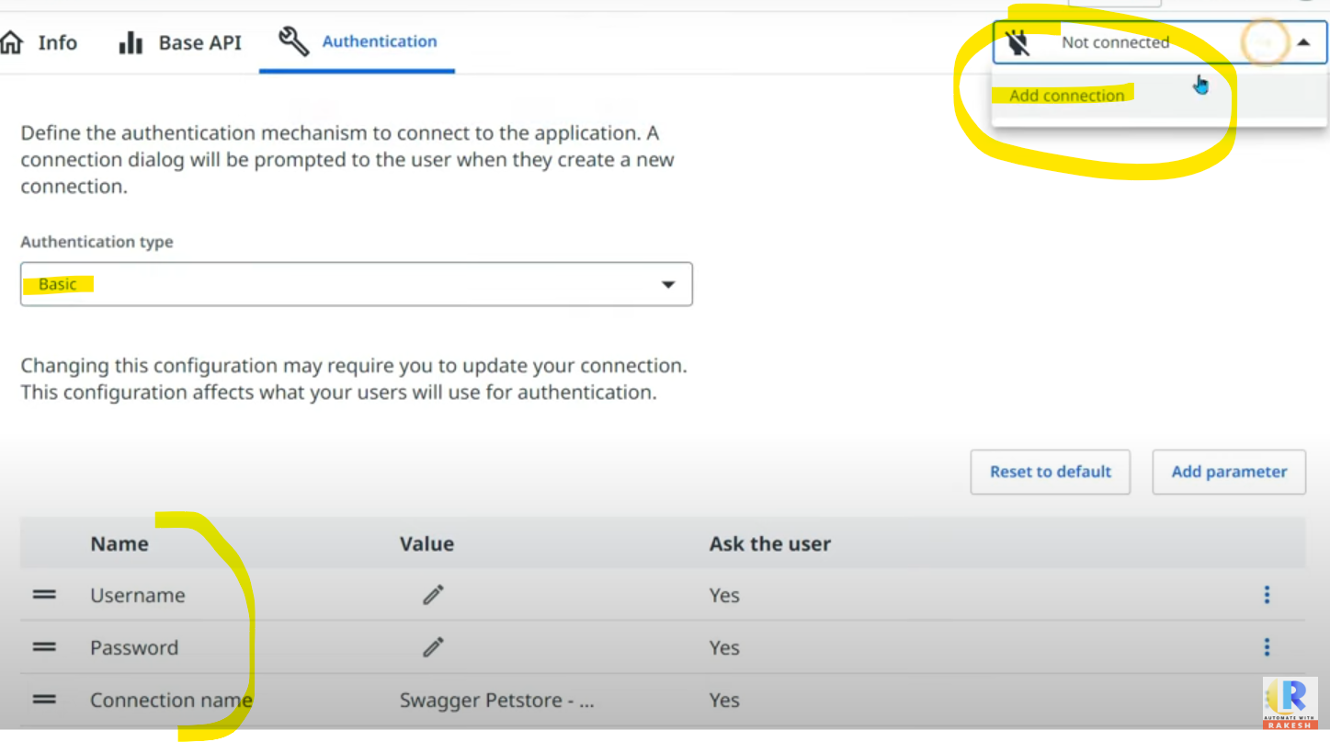

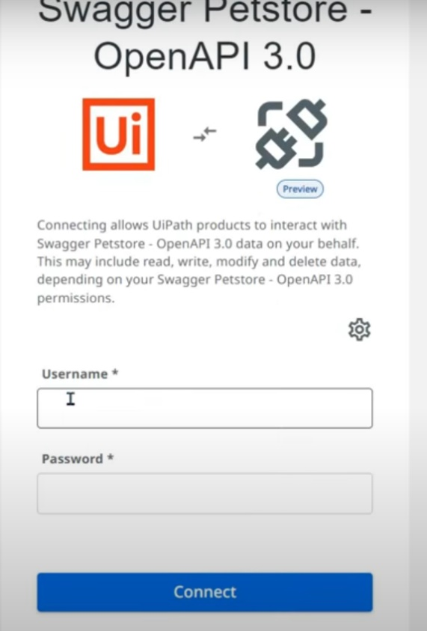

If you choose "API key" & click on "Add connection",

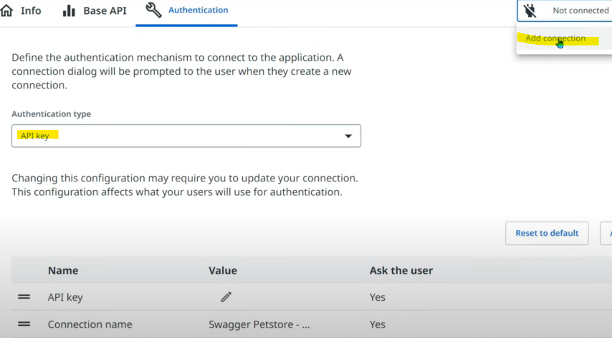

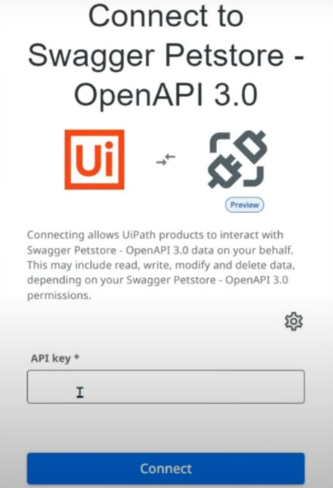

If you choose Personal access token PAT, used for Azure devops etc.

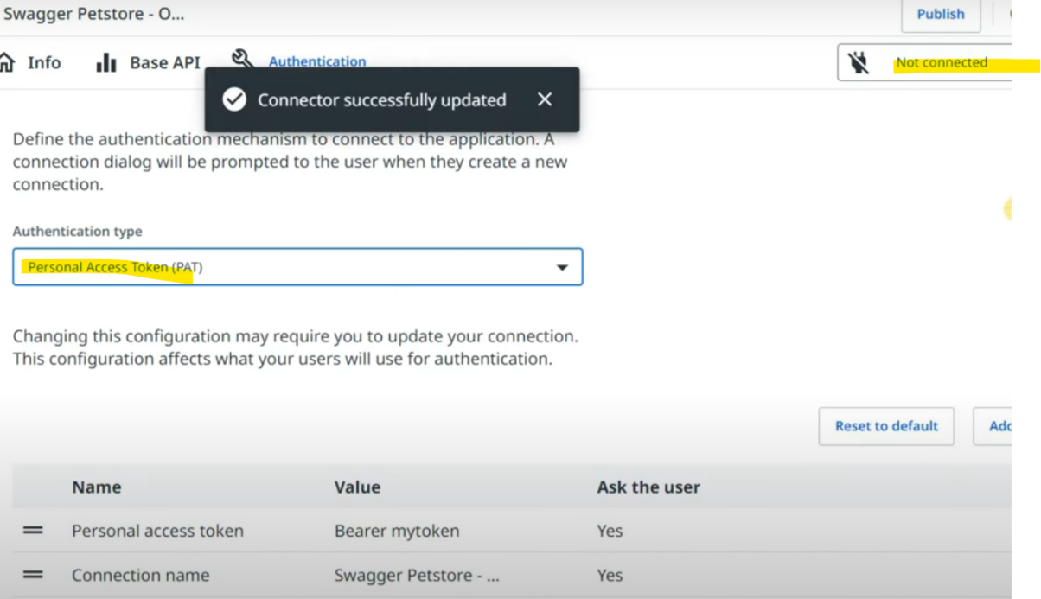

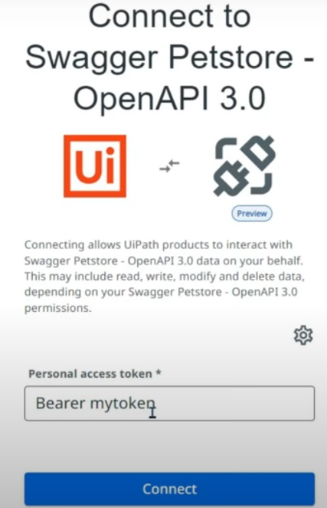

In our scenario, lets use API key as authentication type as the Swagger application provides us API key.

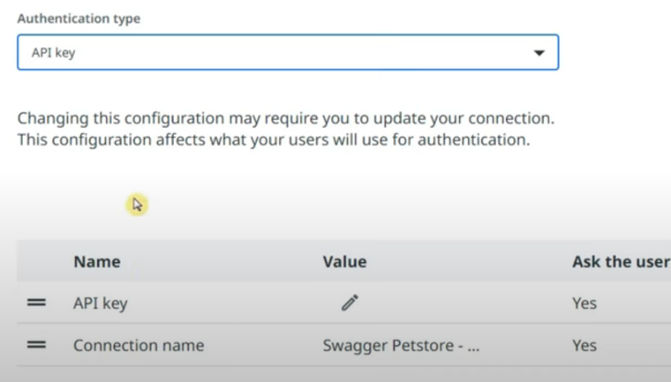

Click on add connection & enter the API key.

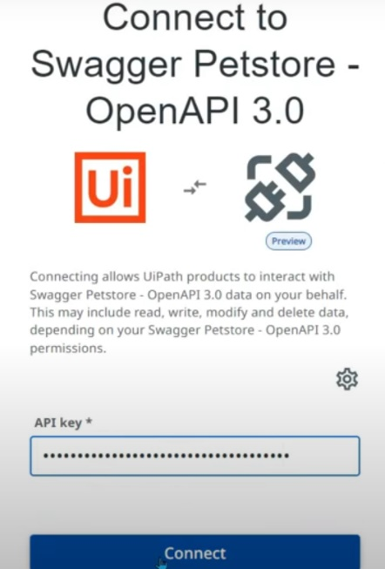

Get the API key from swagger application.

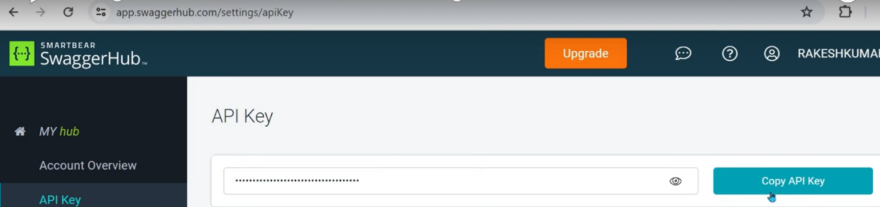

Here in the connector, you can set as ask the user to enter API key every time it connects or edit the parameter.

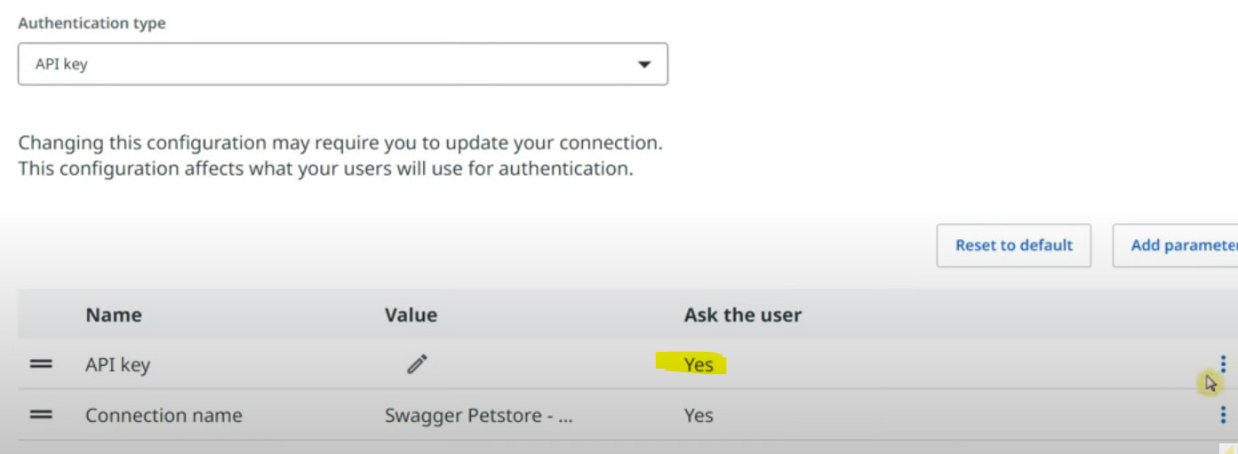

You can set the API key & update NO below & save. So separate users can pass their keys.

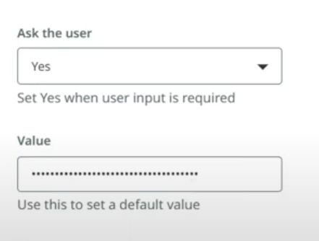

To verify the connection, verify any of the below resources.

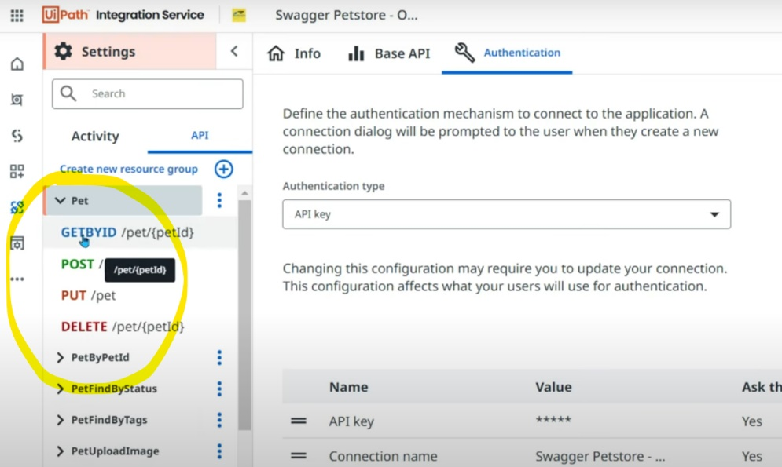

Hit on "Send request"

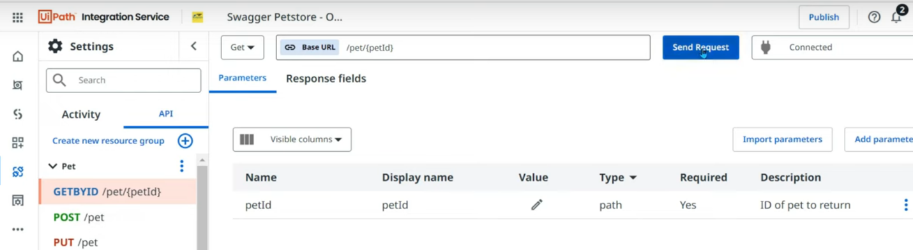

There are 2 tabs in it: Parameters (where you pass inputs) & Response fields.

Parameters: If you provide pet ID then it yields all the fields in response like below.

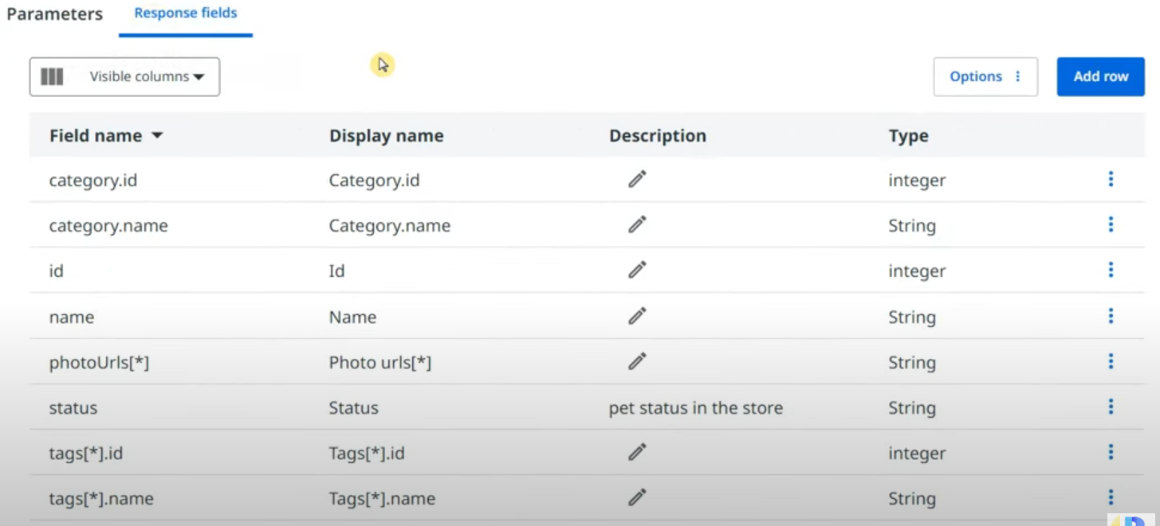

Let's hit on send request & enter input parameters & execute.

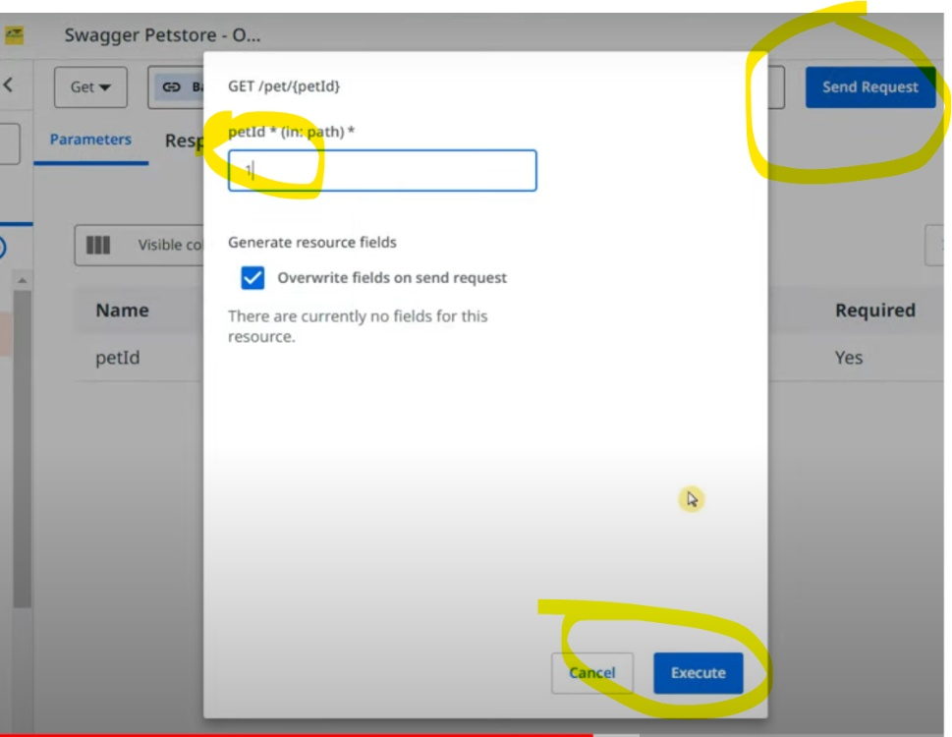

I can see the below response with code success 200.

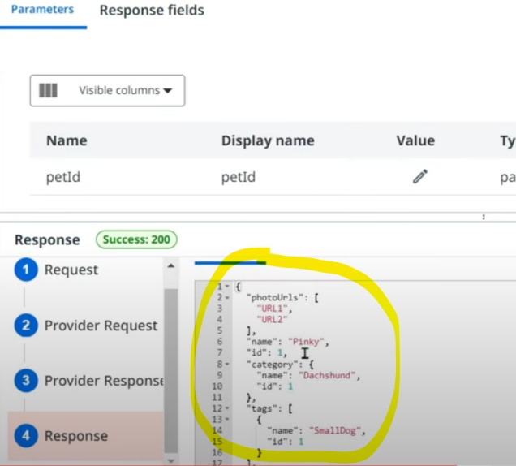

Now our connection is working fine. Click on publish & enter Documentation URL & click on Publish.

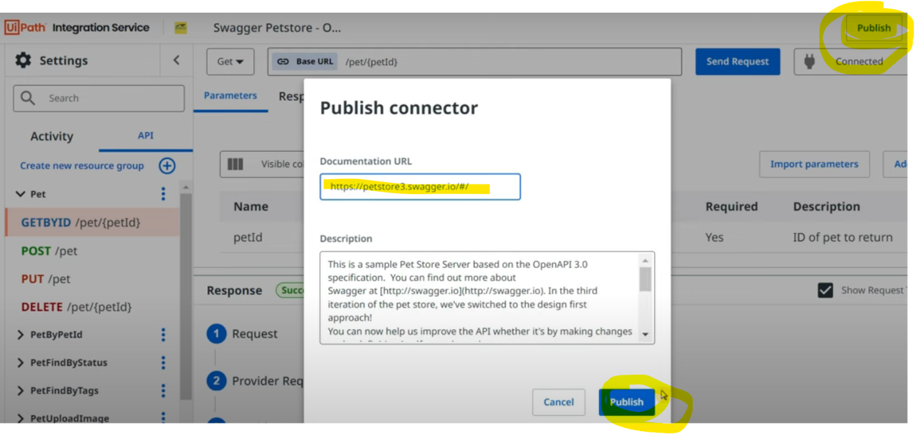

This is the documentation URL

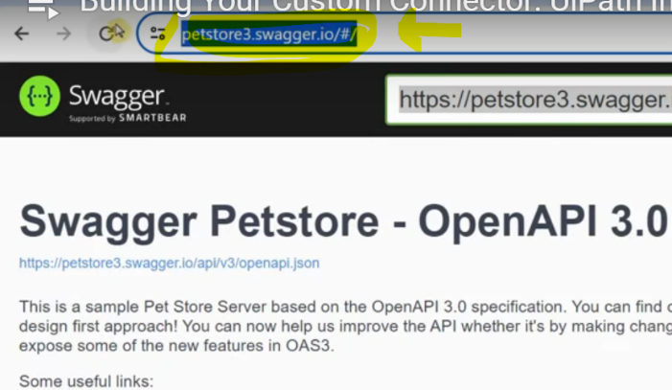

After few seconds you will see the custom connector successfully built.

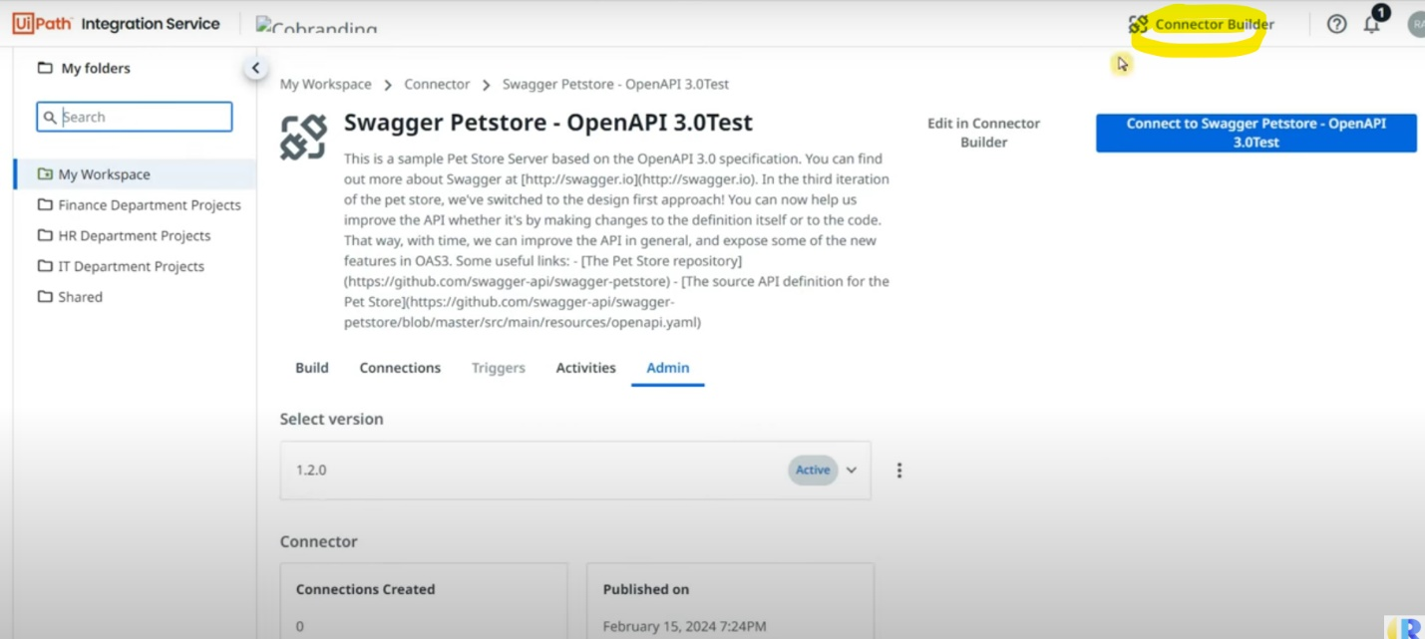

Also you will find the same in connection stab when you search for it.

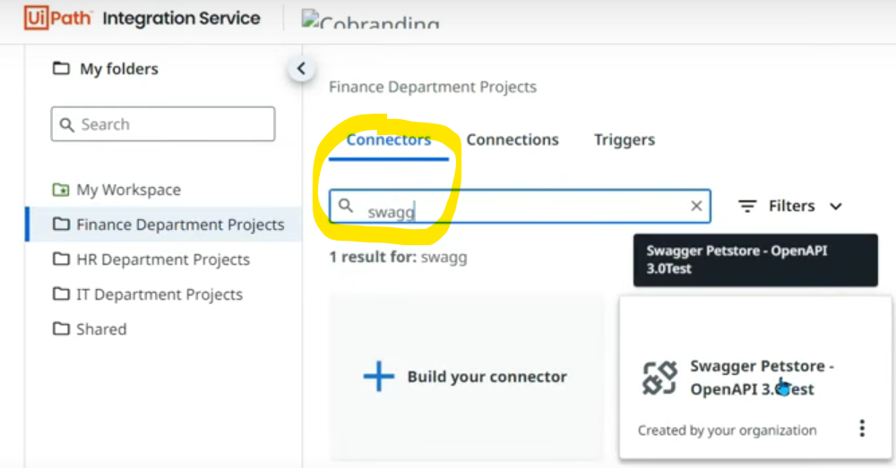

If you open & try to connect you will find below page to enter API key.

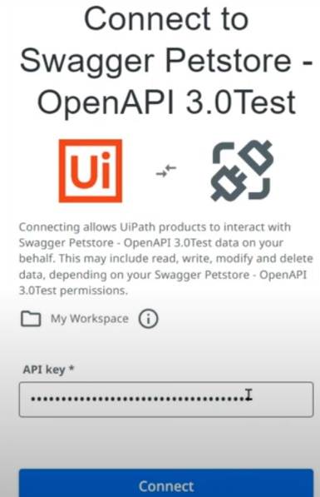

Now Uipath has got integrated with 3rd party application. The Activities tab will show list of activities we can use in Uipath studio.

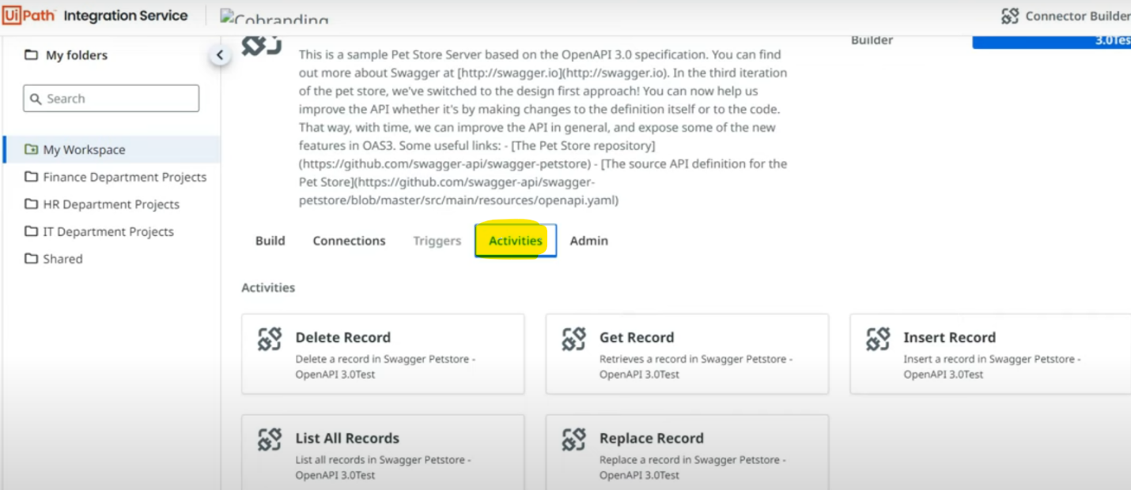

In studio, select the folder (same what we selected in integration service while creating connection) & install the package.

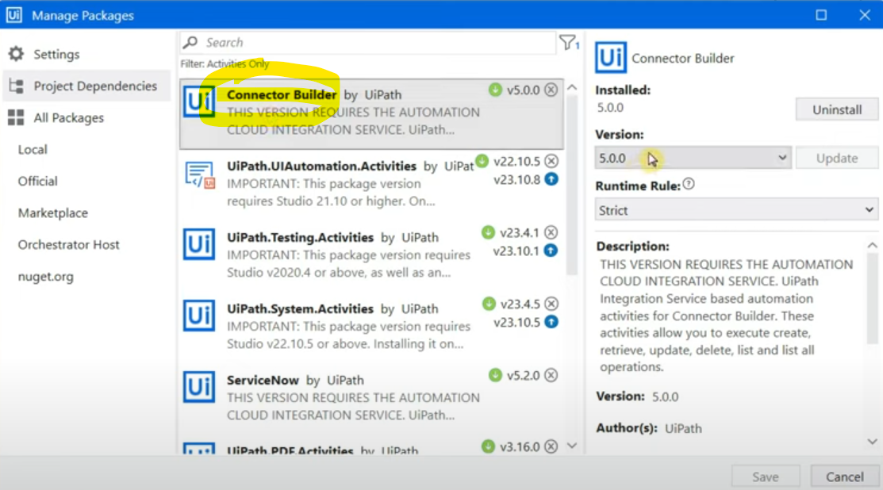

The associated activities are:

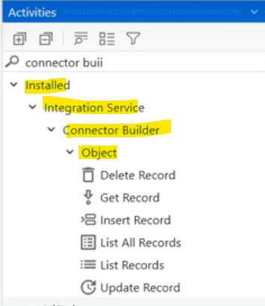

Let's use "Get record" activity & because we are already connected in Integration service & selected the right folder on studio, we can see the results in dropdown automatically.

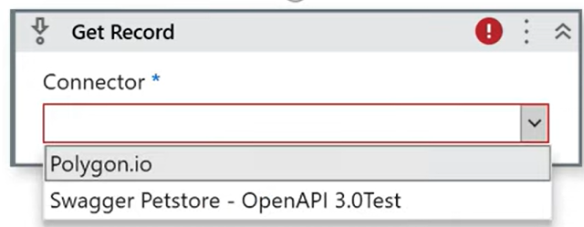

Next it will take the connection name automatically.

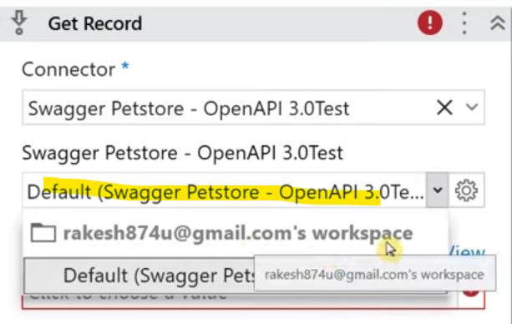

What are the objects? You can see in integration service under this connector.

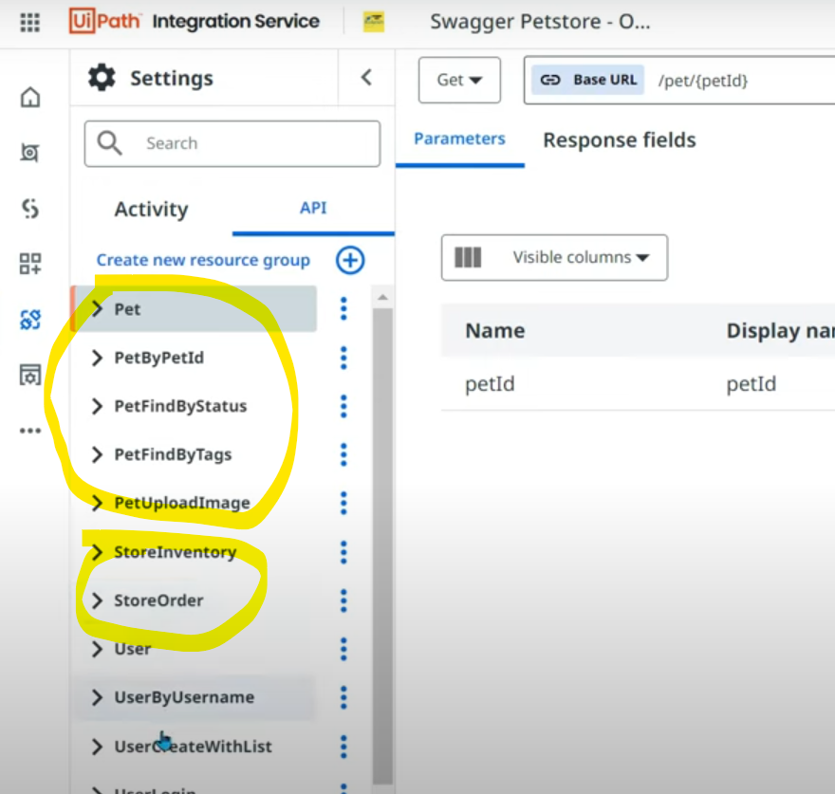

We need to choose in studio, which object we are dealing with. Select the object.

OBJECT: is a table in which we have got certain data.

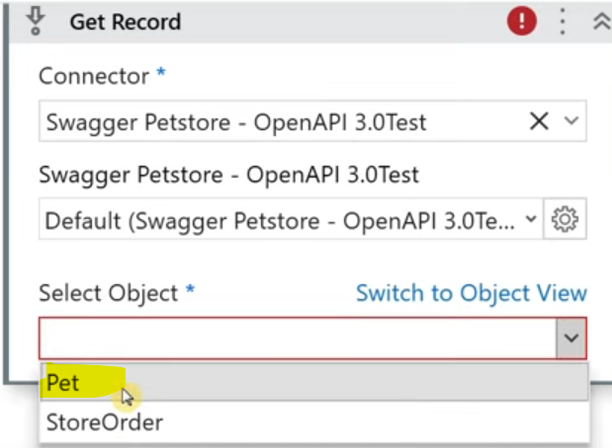

Now the activity gives one more field to select.

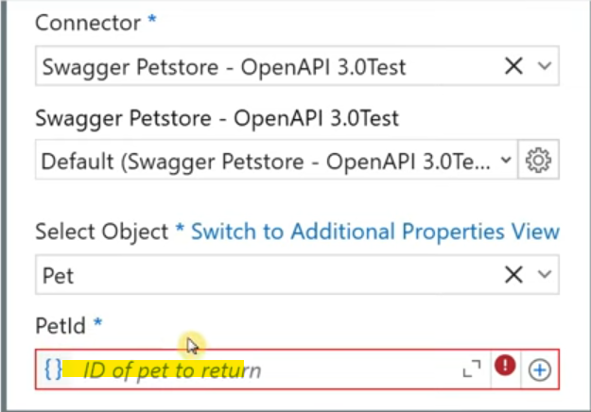

IDs available under Pet object are:

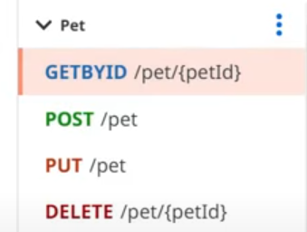

If you see the ID type, it is integer.

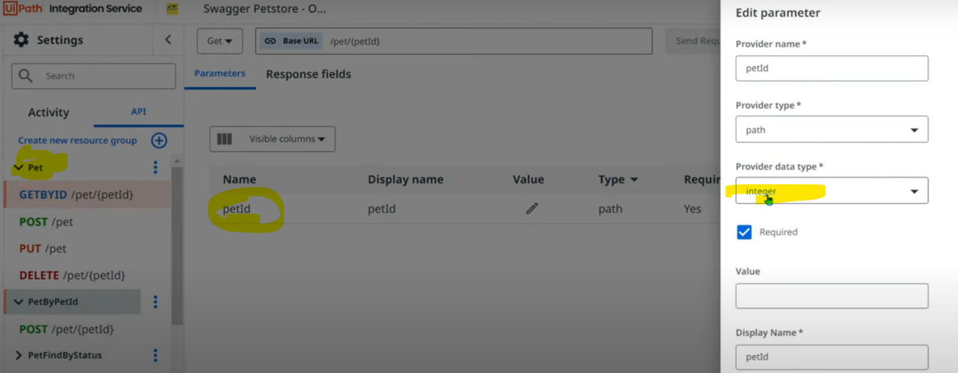

The same you will have to mention in the activity as well. Finally the activity looks like below.

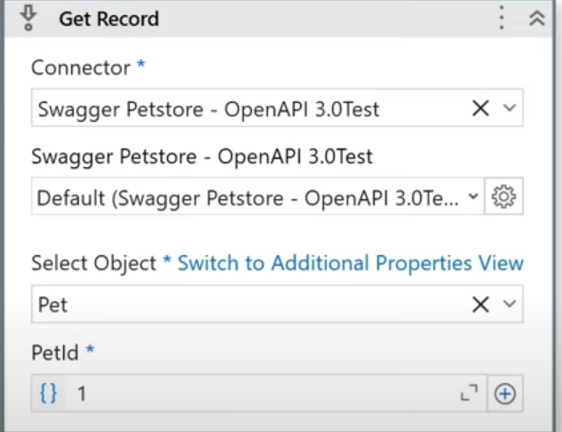

In output property section, if you want to get specific attributes of the output, click on "Switch to Additional properties view" in activity above.

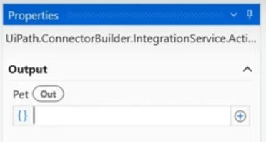

The moment we click, we get below additional field.

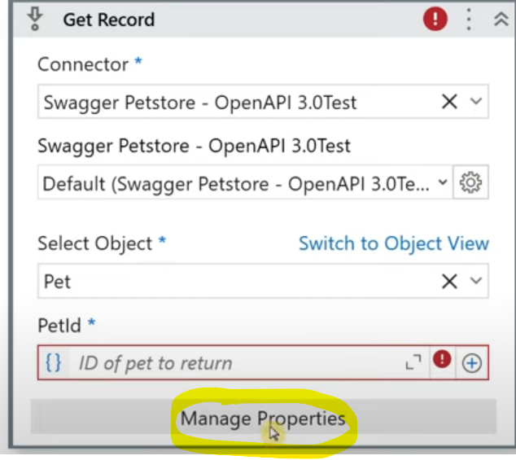

It tells us that the below are various outputs we can get.

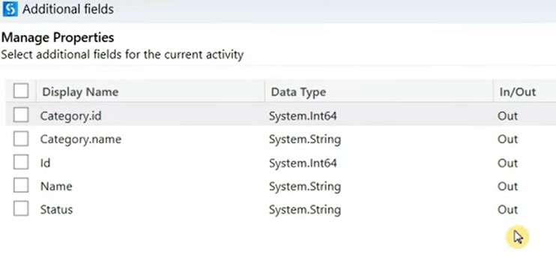

Before we had 1 & now we have 2 outputs in property section, let's create variables.

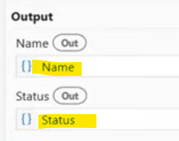

Let's put message box printing both the outputs.

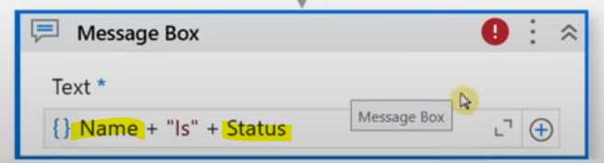

Once you run, you get the below.

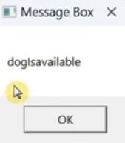

If you give different input (ID - 9) you get different output.

